**DECODER& ENCODER**

***OBJECTIVE:***

* To observe the working of decoder
* To observe the working of Encoder

***THEORY:***

**Decoder**

The process of taking some type of code and determining what it represents in terms of a

Recognizable number or character is called decoding. A decoder is a combinational logic circuit that performs the decoding function, and produces an output that indicates the meaning of the input code.   
**Encoder**

An encoder is a combinational logic circuit that generate n output lines from 2n (or less) inputs. It has the reverse function of the decoder.

***EQUIPMENT / REQUIREMENT:***

* ICs – 7408, 7432 and 7404
* Breadboard
* LED
* DC Power Supply.

***PROCEDURE:***

1. Construct a circuit as shown in *Fig. (1),* set data switches as shown in the two to four line

Decoder output table. Record the output indications of L1 to L4.

2. Construct the circuit as shown in *Fig. (3),* set data switches as shown in the four to two line encoder truth table. Record the output indications of L1 & L2.

**Decoder**

The decoder is an important part of the system which selects the cells to be read from and write into. This particular circuit is called a decoder matrix, or simply a decoder, and has a

Characteristic that for each of the possible 2n binary input number which can be taken by the n input cells, the matrix will have a unique one of its 2n output lines selected.

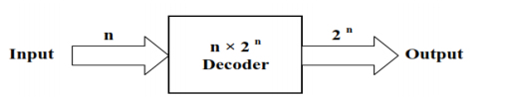

The decoder is called *n* to m where *m < 2n* for example two to four line decoder, *Fig. (1)* Shows a two to four line decoder and its truth table.

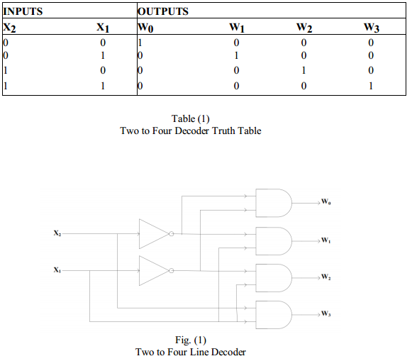

**Encoder**

An encoder accepts digit on its inputs, such as a decimal or octal digit, and converts it to a coded output, such as a binary or BCD. Encoder can also be devised to encode various symbol and alphabetic characters. This process of converting from familiar symbols or numbers to a coded format is called encoding.

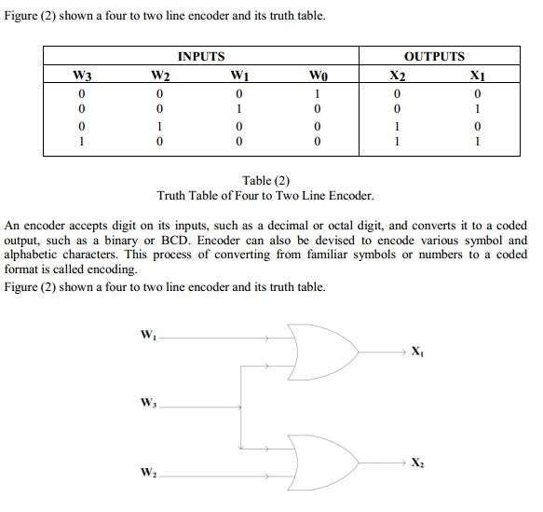

***OUTPUT:***

***CONCLUSION:***